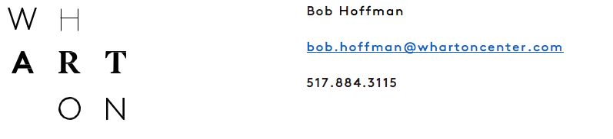

ĭmáGen 2019

Dr. Fox and the impossible cure for death

Date/Time: Saturday, September 21, 2019 at 7:30 p.m.
Sunday, September 22, 2019 at 2:00 p.m.

Location: Wharton Center’s Pasant Theatre

Tickets: Tickets from $18.50
Student discounts available

Ticket Office: whartoncenter.com
517.432.2000 or 1.800.WHARTON

EAST LANSING, Mich. — Broadway stars, local MSU students and high school students are coming together to develop a new musical through the annual program, ĭmáGen. ĭmáGen is a collaboration between Wharton Center Institute for Arts & Creativity and MSU College of Arts and Letters. In its sixth year, this unique program calls for new musical theatre works, selects one show for that year’s program, and then produces a staged concert in three short weeks. This year, the Department of Theatre received its highest number of new work submissions, and the musical chosen is DR. FOX AND THE IMPOSSIBLE CURE FOR DEATH. Tickets for the staged concert are on sale now at Wharton Center’s official ticketing outlets: online at whartoncenter.com, at the Auto-Owners Insurance Ticket Office at Wharton Center, or by calling 1-800-WHARTON.

Kirk Domer with MSU Department of Theatre says, “This program is helping us gain national attention. It’s one of a kind in Michigan and we are so proud of how much it continues to grow. Through this nurturing of a new piece of musical theatre, professional writers and directors are provided the resources and young talent to help develop their show. It’s an educational experience for high school students and college students, an opportunity to work with professionals in show business while still in school.” Bert Goldstein, the Director of Wharton Center’s Institute for Arts & Creativity adds, “Not only have past shows gone on to be produced around the country, but students have continued to work with their Broadway mentors even after graduation. It’s an amazing program and we are all so proud!” Ryan Scott Oliver, a prominent American musical composer, said, “MSU is one of the best in the country for what they offer the new musical.”

The show selected this year, DR. FOX AND THE IMPOSSIBLE CURE FOR DEATH, follows a precocious 13-year-old girl and her overly imaginative father as they search a storybook world for a cure to a brain tumor. This very curious musical twist on the water of life myth was originally conceived at New York University; the selection committee was drawn to the show’s malleability due to how new the piece was. Now, it is up to the creative team that will join forces for three short weeks to bring this piece to life again.

The creative team includes direction by Timothy Koch, who is currently the resident director of Disney’s FROZEN, performing at Broadway’s St. James Theatre. The book and music are by Benedict Braxton-Smith, who is a highly sought-after, Brisbane-based musical director, pianist, composer and orchestrator. Book and lyrics are by Megan Petersen, who most recently has worked on the new musical Benny and Joon at Paper Mill Playhouse where she was the assistant to the lyricist, Mindi Dickstein (Little Women), and the book writer, Kirsten Guenther.
###

Sponsored by University Outreach and Engagement.

